**DAILY ONLINE ACTIVITIES SUMMARY**

|  |  |  |  |  |  |  |  |  |
| --- | --- | --- | --- | --- | --- | --- | --- | --- |
| **Date:** | 01/06/2020 | | | | | **Name:** | D Richard Franklin | |
| **Sem & Sec** | Fourth SEM section A | | | | | **USN:** | 4AL18CS020 | |
| **Online Test Summary** | | | | | | | | |
| **Subject** | | Complex analysis, probability and statistical methods | | | | | | |
| **Max. Marks** | | 30 | | **Score** | | | 23 | |
| **Certification Course Summary** | | | | | | | | |
| **Course** | [Certified Kubernetes Administrator (CKA) with Practice Tests](https://www.udemy.com/course/certified-kubernetes-administrator-with-practice-tests/) | | | | | | | |
| **Certificate Provider** | | | Udemy | | **Duration** | | | 3 Hour |
| **Coding Challenges** | | | | | | | | |
| **Problem Statement:** 1. Calculating nPr value  2. Finding subarrays of an array based on certain condition | | | | | | | | |
| **Status:** Completed | | | | | | | | |
| **Uploaded the report in Github** | | | | | YES | | | |
| **If yes Repository name** | | | | | <https://github.com/richard3658/lockdown-coding> | | | |
| **Uploaded the report in slack** | | | | | YES | | | |

**Online Test Details:**

The online test was from module 5 which was about joint probability distribution and sampling theory. There were 20 questions where 10 was for 1 mark each and the remaining 10 for 2 marks each and the duration was 45 minutes. The questions were optimal and were easy. The score that I got in the test is 23/30.

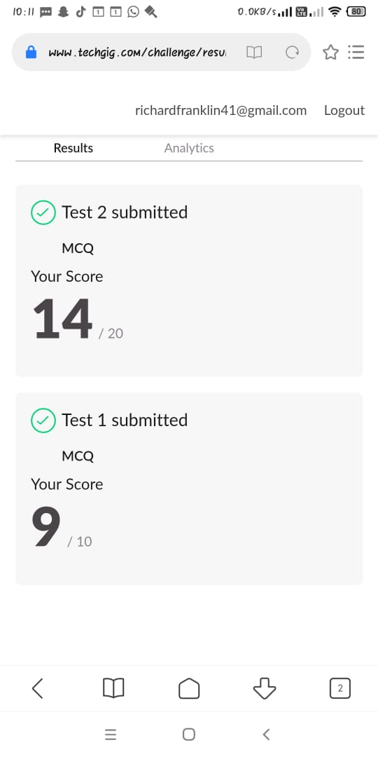

**Certification Course Details:**

**Name of the course**: [Certified Kubernetes Administrator (CKA) with Practice Tests](https://www.udemy.com/course/certified-kubernetes-administrator-with-practice-tests/)

**Certificate Provider**: Udemy

This course has 17 sections and the total duration is 15 hours.

In the thirteenth day I went through the section of the course that explained about troubleshooting, end to end tests and other stuffs related to the network. I also took a mock exam of the course.

**Snapshot:**

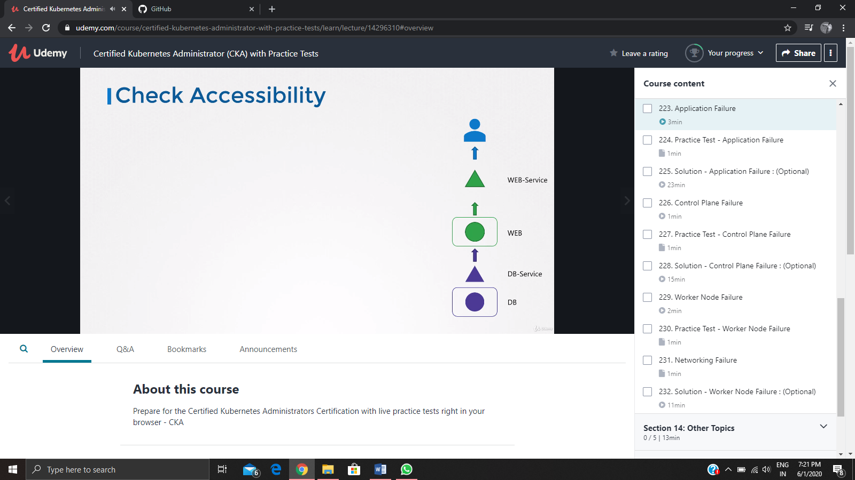

**Online Coding Details:**

Problem 1: (using JAVA) [Write a Java program to calculate nPr.](https://github.com/orgs/alvas-education-foundation/teams/2nd-year/discussions/89)

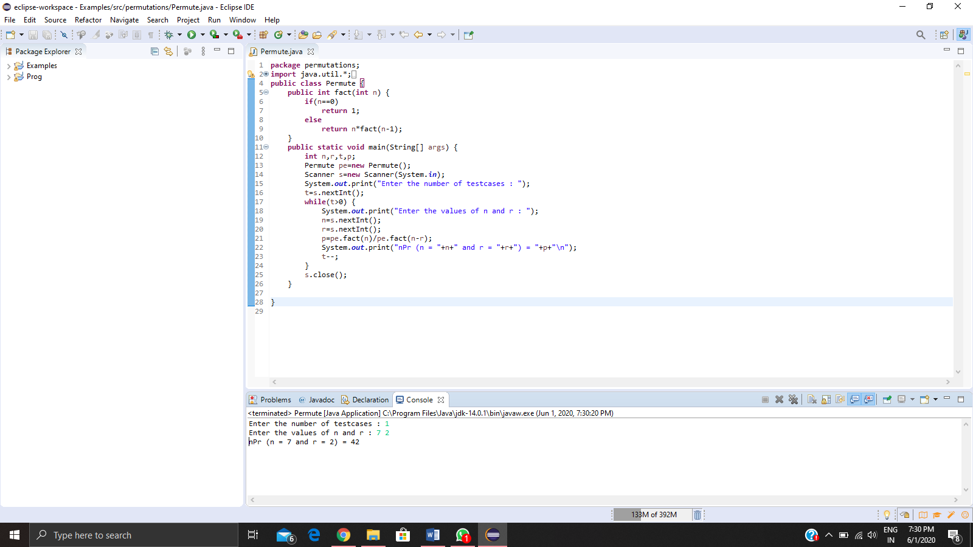

Problem 2: (using JAVA) [Given an array arr[] of size N and an integer K. The task is to find the count of subarrays such that each subarray has exactly K distinct elements.](https://github.com/orgs/alvas-education-foundation/teams/2nd-year/discussions/90)

